Logo in navy that reads: Te Hunga Whaikaha Total Mobility card
A Metlink service

Customer Name

Address 1 November 2024

Kia ora

You have received this letter because you have a Te Hunga Whaikaha Total Mobility card.

We want to let you know we have updated the list of approved taxi companies. There are also new rules for these companies.

They must now:

* Be available to book trips 7 day a week
* Have wheelchair accessible services readily available
* Be available in the evening and on weekends, including wheelchair accessible services
* Not include wait time in the fare amount subsidised by   
  Te Hunga Whaikaha Total Mobility

There is no change to the way you book a trip or the maximum subsidy amount.

If you have any questions or feedback, please call us on   
0800 801 700 or email Info@metlink.org.nz.

Ngā mihi nui,

**Te Hunga Whaikaha Total Mobility Team**

|  |
| --- |
|  |
| Add your email  To get newsletters and updates faster, contact us to add an email address to your details. It could be yours, a family member, or a trusted friend’s email address. |
|  |
| Your card could expire  Your card will expire if it is not used within 3 years with one of our approved taxi companies. Using Metlink bus or rail services does not meet this requirement. |
|  |
| Wheelchair Accessible Vehicle booking  If you have trouble booking a wheelchair accessible vehicle, please let us know the day, time, and taxi company. |
|  |
| Card no longer needed  If you or a family member are a card holder and no longer require this card, please let us know and we can remove you from our database. |

|  |  |
| --- | --- |
| **Approved Taxi Companies** | |
| Wellington Combined Taxis | 04 384 4444 |
| Porirua Taxis | 04 237 6099 |
| Paraparaumu Taxis | 04 296 1111 |
| Masterton Shuttles | 06 377 1923 |
| Masterton Radio Taxis | 06 378 2555 |
| Hutt & City Taxis | 04 570 0057 |
| Golden Oldies Upper Hutt | 04 528 2868 |
| Freedom Companion Drivers | 0800 956 956 |
| Driving Miss Daisy | 0800 948 432 |

Logo in navy that reads: Te Hunga Whaikaha Total Mobility card
A Metlink service

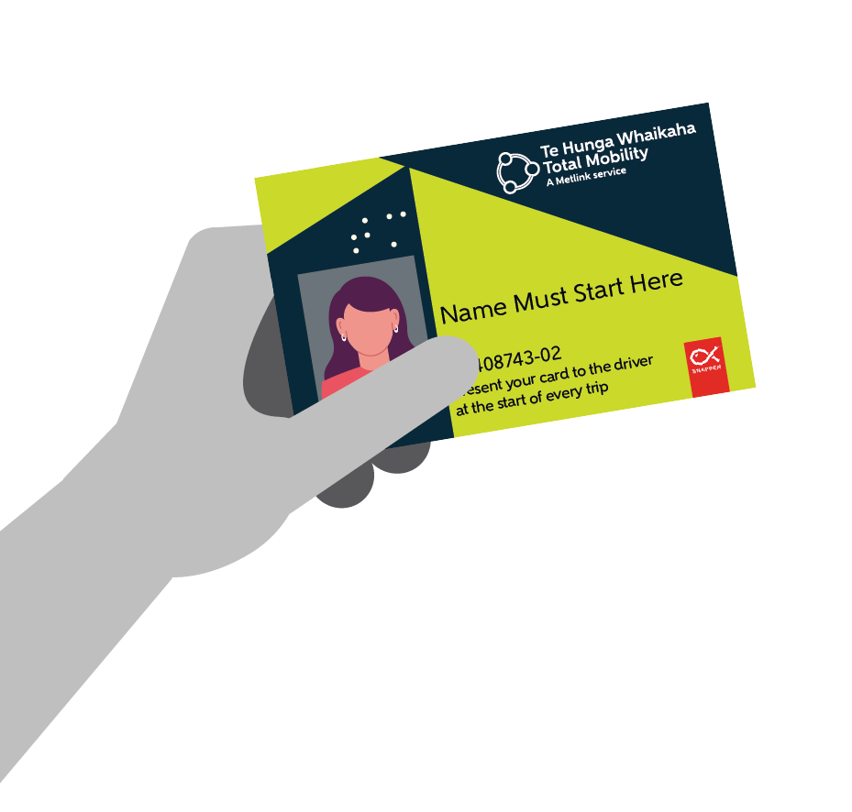All Approved Taxi Companies must be available to book trips 7 days per week including evenings

You can pre-book wheelchair accessible services for trips after 7pm Monday to Saturday or all-day Sunday and public holidays

**Contact Metlink to:**

* Replace damaged or lost cards
* Update address or contact details
* Change or add an email address
* Let us know if there is a change to your mobility or wheelchair use
* Check to see if your card is active
* Add an alternative contact person
* Request a copy of your trip records
* Update your photo
* Give feedback about your trips
* Talk to Metlink about public transport

|  |
| --- |
| Email: info@metlink.org.nz |
| Phone: 0800 801 700 |
| Web: www.metlink.org.nz |

The Metlink Contact Centre is open from 8am to 8pm every day except Christmas Day.